GL and Budget vs. Actuals Markdown File Instructions

How to use this document
This markdown file will use the DHCD Finance dept documents that are for reporting expenditures and GL data. The data is collected from Workday. I will be referring to each of the code chunks (the code chunk refers to anything that is located within the ```{r} ``` area) within the file and add more detailed information on how to complete each of the r code chunk actions.
Follow along with the rmarkdown file named All_Service_Centers_GL_and_Budget_vs_Actuals
The following information will prep you for downloading the data and using the Rstudio application!

IMPORTANT!! Make sure to follow the steps closely!!!

Data Prep from Workday to your dhcd folder
- Wait until 3 days after the books close as more entries or changes may be made before reading the data into R.
- When you download the raw data from the Workday program make sure that you are getting the Annual Report and your DHCD department not just the monthly report because this is the only way the reports will be able to work in R.
  - Data extraction from Workday
    - The Workday parameters should be as seen below:
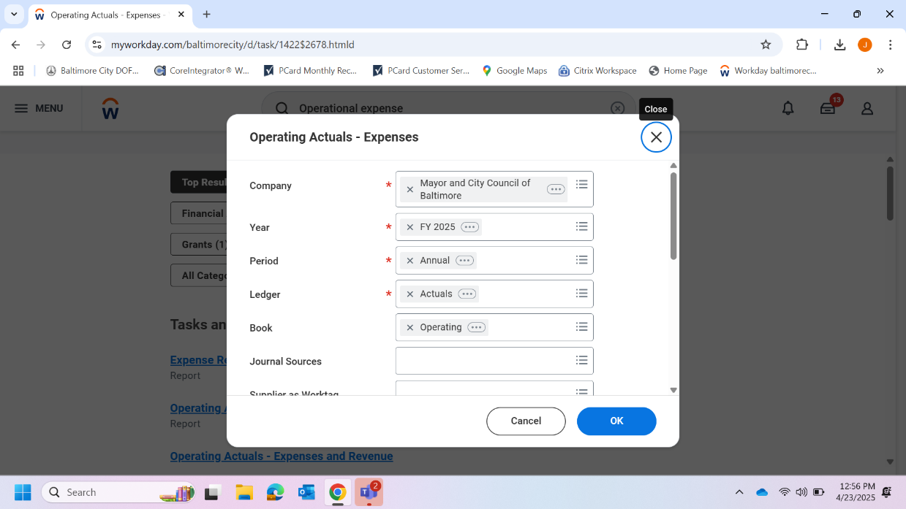
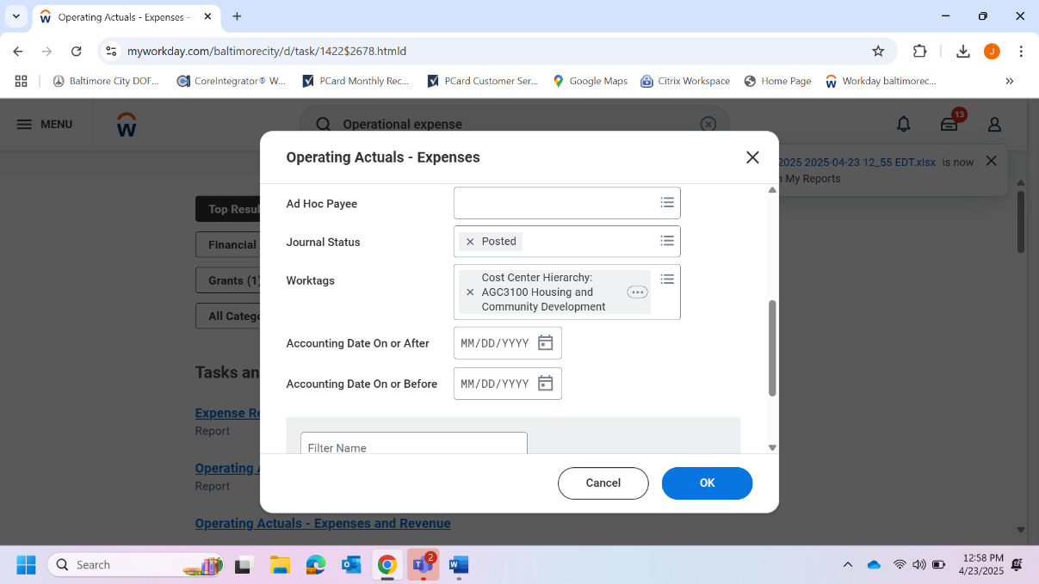
      - GL Report Workday Parameters
  - BBMR Report Workday Parameters
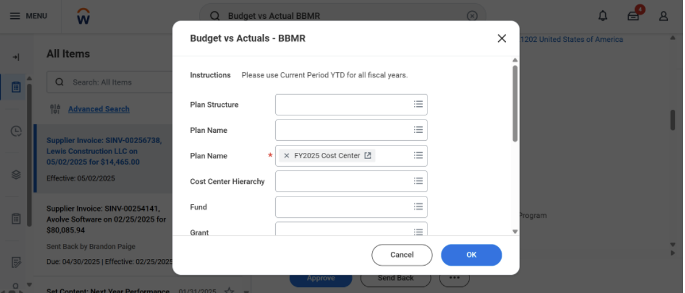

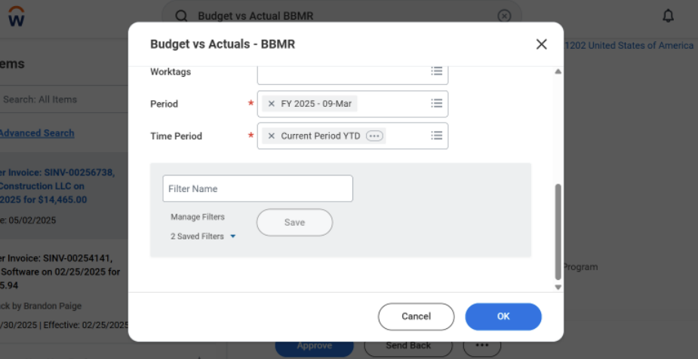

- Excel data tables for the GL and BBMR file should look these photos below with the extraneous rows and headers. DO NOT ALTERNATE THE DATA AT ALL! DO NOT ADD IN ANYTHING AT ALL AND DO NOT DELETE THE HEADERS IN THE GL!

  - The file must look like this with extra rows.
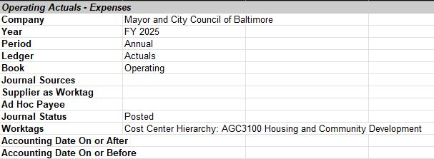
    - GL-Operating Actual Expenses YTD

  - The file must look like this with extra rows. Delete ROWS 1-11 ON THE BBMR REPORT TO LOOK LIKE THE PHOTO BELOW!
    - Budget_vs_Actuals_-_BBMR YTD
    - The BBMR file will need to have the headings look like below here. DO NOT DELETE THE COMMITMENTS OR OBLIGATIONS COLUMNS (R WILL DO THAT FOR YOU)!

- Please change the name of the files that you are reading into R based on what you are trying to complete for the analysis. Do not add any spaces that are not necessary!
  - Example: gl_file_name <- "GL-Operating Actual Expenses YTD 2024-12-19.xlsx" – Change the month. The month date will change depending on the date the data was downloaded.
  - Example: budg_vs_act_file_name <- "Budget_vs_Actuals_-_BBMR YTD 2024-12-19.xlsx" – Change the month. The month date will change depending on the date the data was downloaded.
- Then put the files in the Data folder as this will connect to the R rmd file directly.
  - The Data folder is located in the dhcd folder as shown below.



Rstudio Prep
- Now open the dhcd_finance project file within the dhcd_finance folder as shown below.

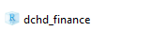
- Rstudio will open up. Now navigate to the files folder seen here. It will be a pop-up on the screen.
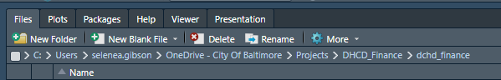

- After the files tab has been opened, click on the RMD file that will be used. Navigate to the rmd file as shown below.

- Click on the file and then minimize the Files pane as shown below.
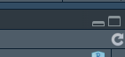
Click on this here to minimize the pane (Inside the red circle)

- Use Control + Alt+ R to run the entire script or go line by line if you’d like to complete the process of running the rmd file.
  - If running line by line make sure to place the cursor on the line that you want to run.
- IMPORTANT! YOU MUST RUN THE LIBRARIES FIRST IN ORDER FOR THE RMD FILE TO WORK. NO LIBRARIES RAN = NO OUTPUT FOR R!!!

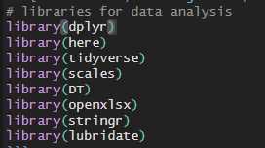

- After everything has been ran your output files will be in the dhcd_folder as shown below.
Note that the dates/months will change depending on the date that the data is for.

R Chunks
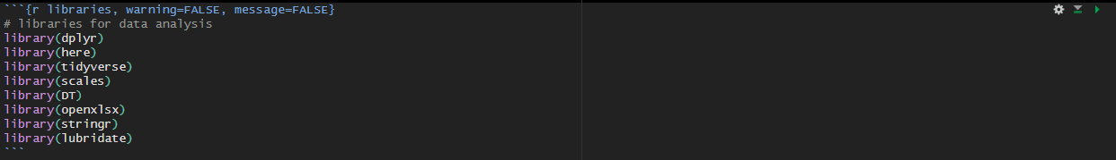
- R code chunks can be used as a means render R output into documents or to simply display code for illustration. Here is a simple R code chunk that will result in both the code and it’s output being included:

- The chunk begins with ``` {r chunkname}
and ends with ```

  - PLACE YOUR CURSOR AT THE BEGINNING OF THE LINE BELOW THE ``` {r chunkname} AS SHOWN BELOW IN THE RED CIRCLE
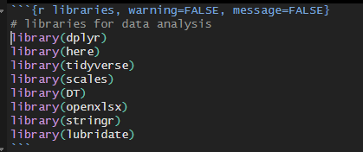
- It might be a lighter or darker color on your screen for where the chunk begins and ends. Run everything within the chunk.

Side quest with cheat codes
Please use this once you have understood the r code and what it does.
- Cheat code
  - Use cntrl + alt + R to run the whole RMD file
- Cheat Code

  - Use the Green play button to run just the current chunk

